Assignment 6-4

# Task-1

Task Description #1:  
• Start a Python class named Student with attributes name, roll_number, and marks. Prompt  
GitHub Copilot to complete methods for displaying details and checking if marks are above  
average.

Code

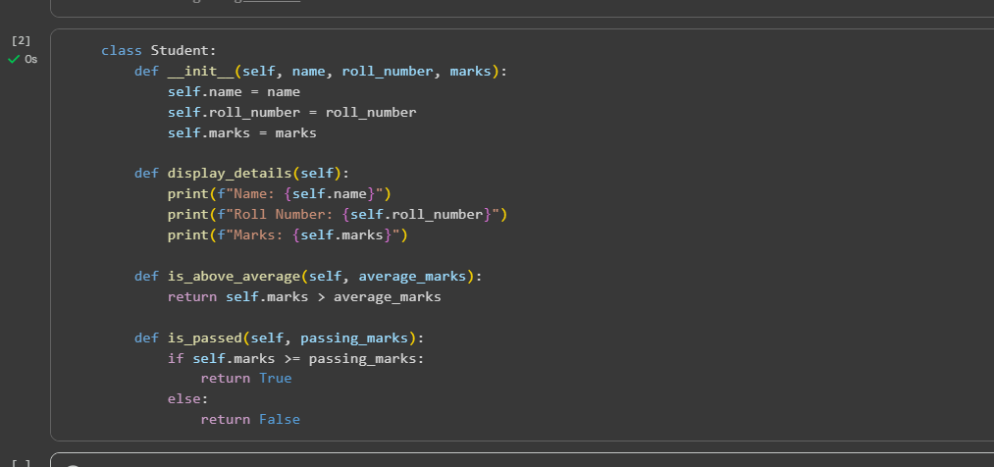

Task-2

Task Description #2:  
• Write the first two lines of a for loop to iterate through a list of numbers. Use a comment  
prompt to let Copilot suggest how to calculate and print the square of even numbers only

# Code

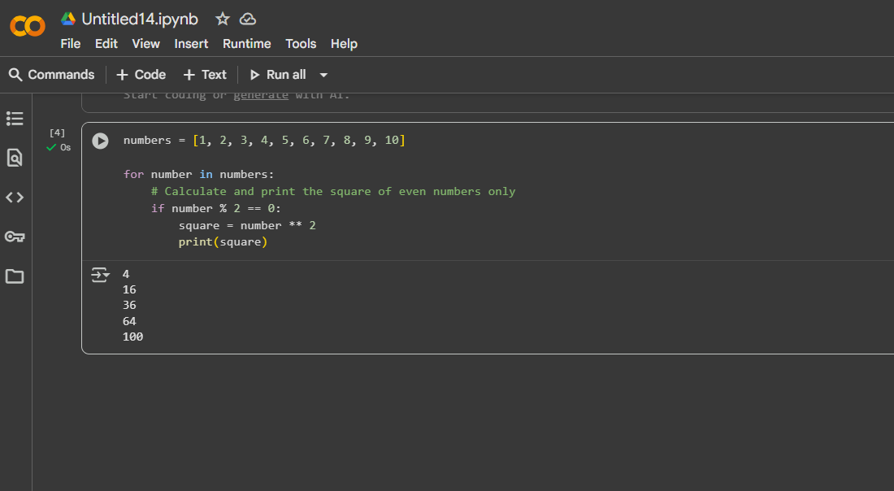

Task-3

Task Description #3:  
• Create a class called BankAccount with attributes account_holder and balance. Use Copilot to  
complete methods for deposit(), withdraw(), and check for insufficient balance.

Code

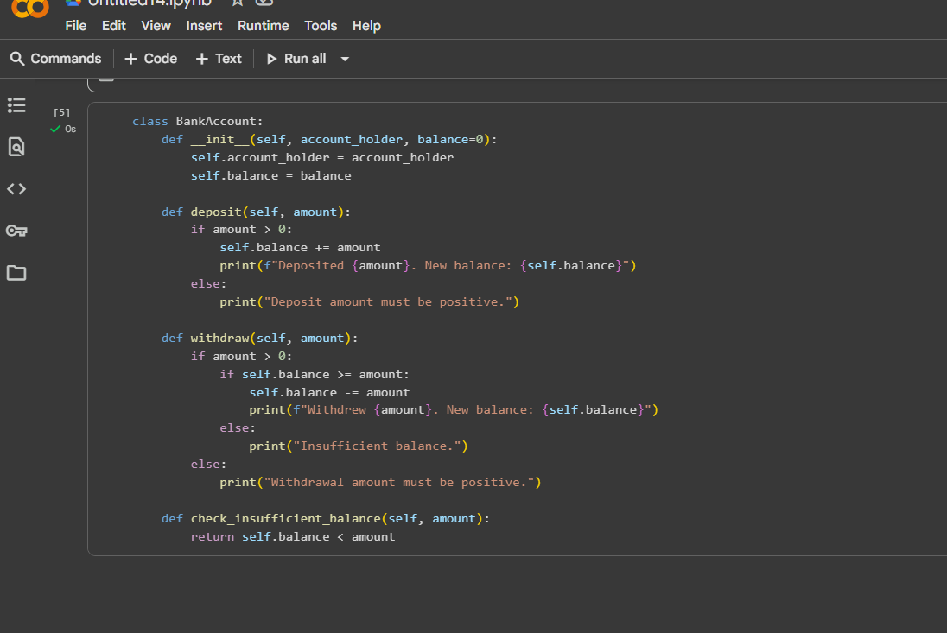

Task-4

Task Description #4:  
• Define a list of student dictionaries with keys name and score. Ask Copilot to write a while  
loop to print the names of students who scored more than 75

# Code

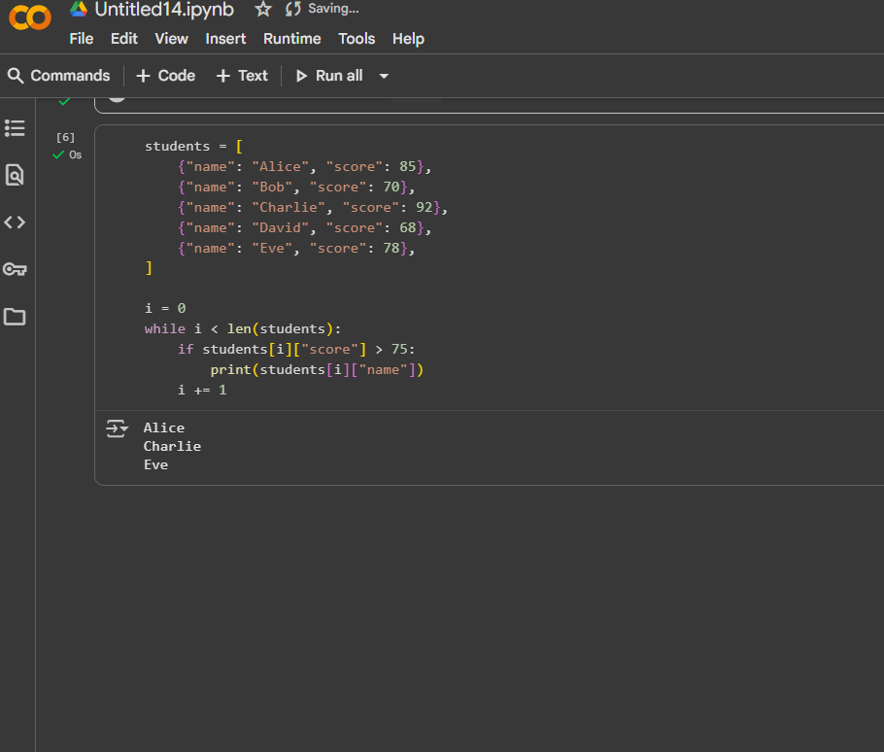

Task-5

Task Description #5:  
• Begin writing a class ShoppingCart with an empty items list. Prompt Copilot to generate  
methods to add_item, remove_item, and use a loop to calculate the total bill using conditional  
discounts

# Code

